Part 3: New Dams & Diversions in the Alpine Lakes Wilderness?
January 7, 2015 by naiads

Part 3: The Upper Klonaqua Lake Pipeline Proposal

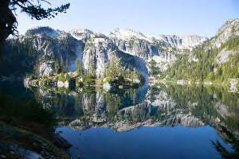
Upper Klonaqua Lake (Aspect Consulting, Nov. 2014)

This is the third of a four-part series regarding proposals to re-build a dam and increase water diversions from as many as seven lakes in the Enchantment Lakes region of the Alpine Lakes Wilderness. Part 1describes the genesis and functioning of the Icicle Work Group, the entity which is proposing the water projects. Part 2examines the Eightmile Lake Restoration-Storage project, and Part 4 examines the Alpine Lakes Automation-Storage project.

In a nutshell, the Department of Ecology’s Office of the Columbia River has funded Chelan County to investigate how to solve water problems in the Wenatchee River watershed. The primary focus of the effort is to increase water storage and diversions from seven lakes in the Enchantment Lakes region of the Alpine Lakes Wilderness.
\
This article discusses the preliminary proposal to divert water out of Upper Klonaqua Lake. The only study for this project released to date is the draft Bathymetry and Topographic Survey of Upper Klonaqua Lake and Conceptual Release Options (Aspect Consulting, Nov. 2014).

As with all of the Alpine Lakes proposals, the search is on for new water to supply downstream uses in the Icicle Creek and Wenatchee Valley.

The Upper Klonaqua Lake concept involves installing a siphon or pump or blasting a tunnel from Lower Klonaqua into Upper Klonaqua Lake, draining it into Lower Klonaqua Lake, and then allocating that water for uses further down in the watershed.

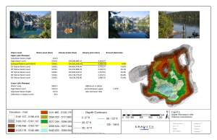
Upper Klonaqua Lake Bathymetry Synopsis (Aspect Consulting, Nov. 2014) Draft

In September 2014, Gravity Consulting LLC conducted a study of the depth and contours of Upper Klonaqua Lake.

As discussed in Parts 1 and 2 of this series, the Icicle and Peshastin Irrigation Districts (IPID) hold some form of water rights and easements for several Alpine Lakes, including the Upper and Lower Klonaqua Lakes. IPID has never accessed water from Upper Klonaqua, and according to the report, has used only 1,600 acre-feet of its 1926 2500 acre-foot water right from Lower Klonaqua Lake.

Nonetheless, the Upper Klonaqua Study evaluates the natural storage capacity of Upper Klonaqua, including how much water could be obtained by drawing down the lake.

Issues with this proposal include that any new water project in a wilderness area would require approval of the U.S. Forest Service (and, according to the Wilderness Act of 1964, possibly the U.S. President).

And, because this proposal would involve diverting increased quantities of water from the Klonaqua Lakes, the Department of Ecology would have to evaluate relinquishment, and issue new water rights to accomplish the goal.

To date, neither the Forest Service nor the Department of Ecology have expressed opinions about the viability of these proposals.

